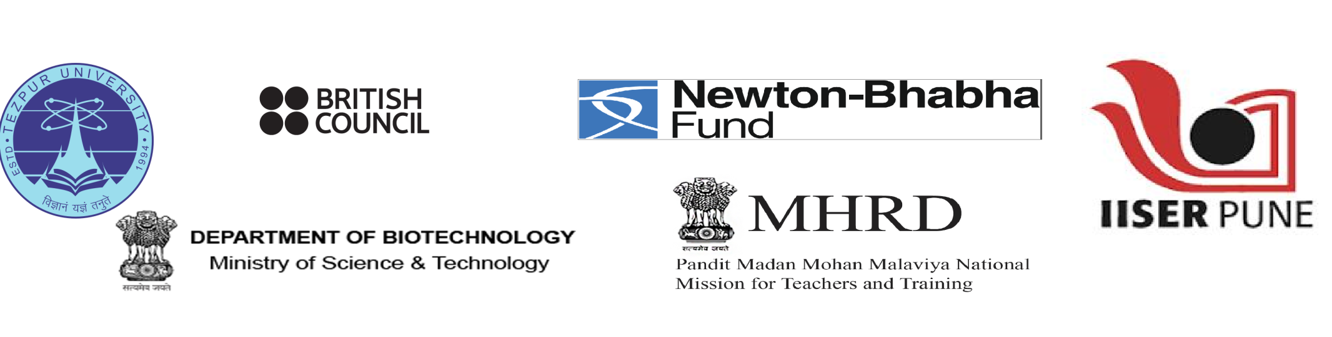
Training Workshop on Research Based Pedagogical Tools (RBPTs) for Teachers of Undergraduate Science Courses
28th to 30th January 2017
At
Teaching Learning Centre (TLC), Tezpur University
(Last Date of Online Application: 30/12/2016)

Teaching Learning Centre (TLC), Tezpur University, jointly with Indian Institute of Science Education and Research (IISER), Pune and the British Council, is organizing a three-day pedagogy workshop for undergraduate science teachers from January 28-30, 2017 at Tezpur University.
This is a great opportunity for professional development for all teachers and the chance to interact with their counterparts from various colleges and education experts from India and learn from each other’s experience. We urge you to utilise this opportunity. From the tools developed during the workshop, scalable tools that could be deployed by other teachers will be identified and added to a national database. Selected participants will also get to participate in a Level 2 workshop later, that will focus on making them trainers for conducting similar trainings at local level.
Target Group: The workshop is meant for teachers of all disciplines such as physics, chemistry, mathematics, biology and earth sciences. It will introduce participants to research-based pedagogical tools that focus on the process of science rather than facts. It will be a hands-on workshop with participants preparing their own teaching tools in groups and reviewing those of others. The teachers will also get an opportunity to share their own teaching innovations with their peers and experts in the field.
Resource persons: The workshop will be conducted by a team of trainers from the Sheffield Hallam University, UK and Indian experts from the area of education and policy.
Eligibility Criteria: Teachers teaching in government or government-aided colleges with either a master’s degree with 10 years of teaching experience or a PhD degree with 5 years of teaching experience are eligible to apply. Interested teachers are requested to apply online at the link given bellow. A short ‘Statement of Purpose’ about why they would like to participate in this workshop and whether/how they would like to be involved in spreading this pedagogical innovation among their peers later, must be submitted with the online application. The organisers will select 150 teachers from the applications received. Selected candidates will have to submit scanned copies of supporting documents (Recommendation from the Principal/Head of Institute/Proof of PhD Degree) once they are selected. The college is also expected to support the participants in this activity.
Accommodation and TA: All participants will be provided food and accommodation at Tezpur University Campus from 27th evening to 31st morning. There are no charges to the participants selected for this workshop. Funds permitting, TA will be given to all participants.
How to Reach:The University is well connected with the rest of the country by rail, road and air. However, the main connection is through Guwahati, the capital city of Assam. The distance from Guwahati to Tezpur is 186 kms.

Weather: In January weather in Tezpur will be moderately cold. Participants are advised bring warm clothes.
Schedule Summary: 1. Inauguration (27th January 2017 Evening)
2. Workshop (from 28th to 30th January 2017)
Link for Online Application by Individuals:
https://docs.google.com/forms/d/e/1FAIpQLSfEZxJyYUDjSsXlNieZJXQa2G371gZYwzDI1-aGojlFpkip-w/viewform
For any Query and Clarification please contact us at:
Email: rbpt@tezu.ernet.in
Phone: +913712275681
Tezpur University Website: www.tezu.ernet.in
Last Date of Application: 30-12-2016
Thank you.
With best regards,
Prof.Prasanta Kumar Das
Director
Teaching Learning Centre
Tezpur University

Recommendation from the Principal/Head of the Institute

I hereby certify that : Dr./Mr./Ms……………………………………………………………………………….is an
………………………………………………(Designation)in………………………………………………………...(Subject)
Serving since………………….. His/her service is Permanent/Contractual/Temporary.
(a) Our College/Institute Comes under the purview of Section 2(f) of the UGC Act or has been affiliated to
..................................................................University.
(b)Our college/Institute is a government/government-aided College/Institute
(c) The applicant has the teaching experience of ……………..years in Undergraduate Courses.

Signature of the Principal/Head
Office Seal
Date:
Place:

